

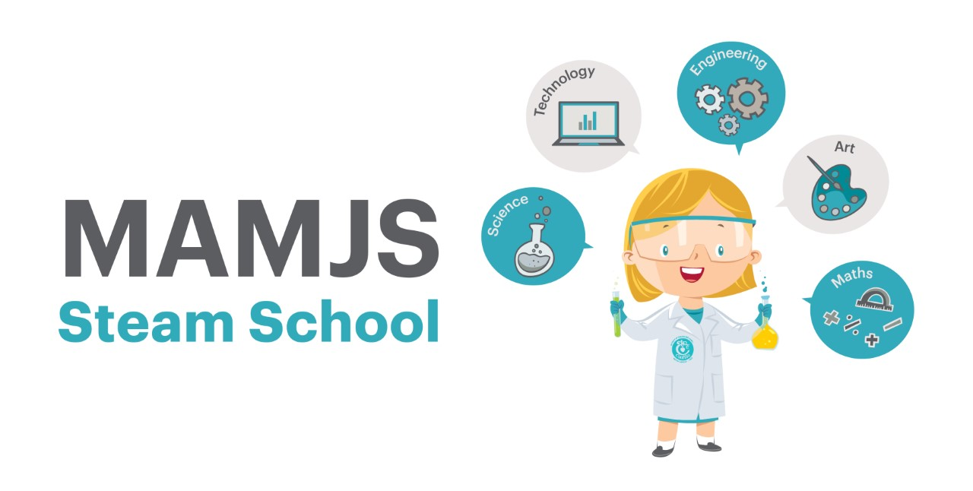

Dear Parents,

On Monday we had a talk all about sharks where we actually found out that they are not that scary! Jenny from Sharks4Kids explained that sharks are made from cartilage and not bones. Their bodies are made from dermal denticles, which are just like tiny teeth. Sharks also have the ability to grow back their teeth.

Speaking of teeth, we had Dr. Svetlana Kilgannon a dentist from Smart Dental come in on Wednesday and speak about the importance of dental hygiene and how best we can take care of our teeth, because unlike sharks, our adult teeth don’t grow back.

5th class hosted their annual Science Fair on Tuesday. We learned so much about bacteria, vinegar rockets, colour explosions and some girls even made their own lava lamps. A huge well done to the 5th class pupils and teachers, it is always one of the highlights of STEAM Term.

Thursday saw the parents take the floor. At the Parents’ Science Fair, the theme of Climate Change & Sustainability was clearly evident. We had upcycling fashion stalls, a pledge tree to become more sustainable, we made bee bombs along with some marble artwork. A huge thank you to the parents who worked endlessly to make the day a huge success, which was enjoyed by all.

Today was magic! We had Martin Scott at assembly this morning who gave us eight interesting facts. We learned about famous female scientist and coders. We found out that turtles in the Cayman Islands are protected by people in Co.Carlow. Technology set up in beaches where the turtles live are monitored by NetWatch to ensure they are safe and unharmed. Martin finished up his presentation with a Maths Magic trick, take three different numbers between 1-9, reverse them and take away. Then reverse your answer and add your two answers. 1089 should always be the magic answer.

Ciara & Leah

I.T Coordinators

With many thanks to our STEAM committee